**Remote Debugging Azure Web App**

Step 1: Create any new project from Visual Studio template

Step 2:

WebForm1.aspx

<body>

<form id="form1" runat="server">

<div>

<asp:Button ID="btnClick" Text="Click Me" OnClick="btnClick_Click" runat="server" />

<asp:Label ID="lbl1" runat="server" />

</div>

</form>

</body>

WebForm1.aspx.cs

protected void btnClick_Click(object sender, EventArgs e)

{

string mytext = "Microsoft Azure";

lbl1.Text = mytext;

}

Step 3:

Now set the debug point on button click

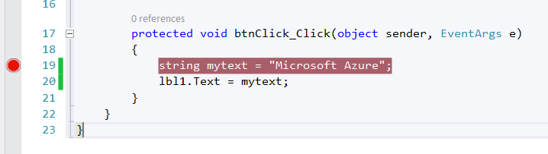

Step 4: Right click on Project name & select “Publish” option

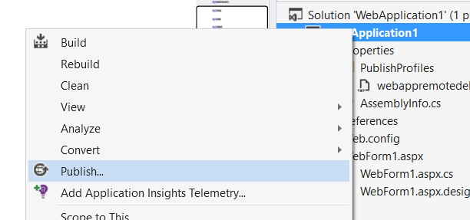

Step 5: Select publish target - Microsoft Azure Web Apps

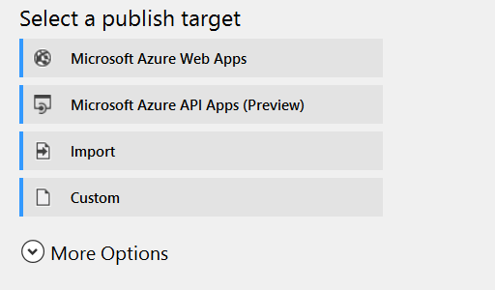

Step 6: Select existing web app from list or create new web app.

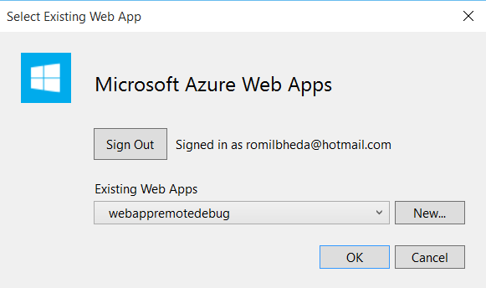

Step 7: Click on Next button

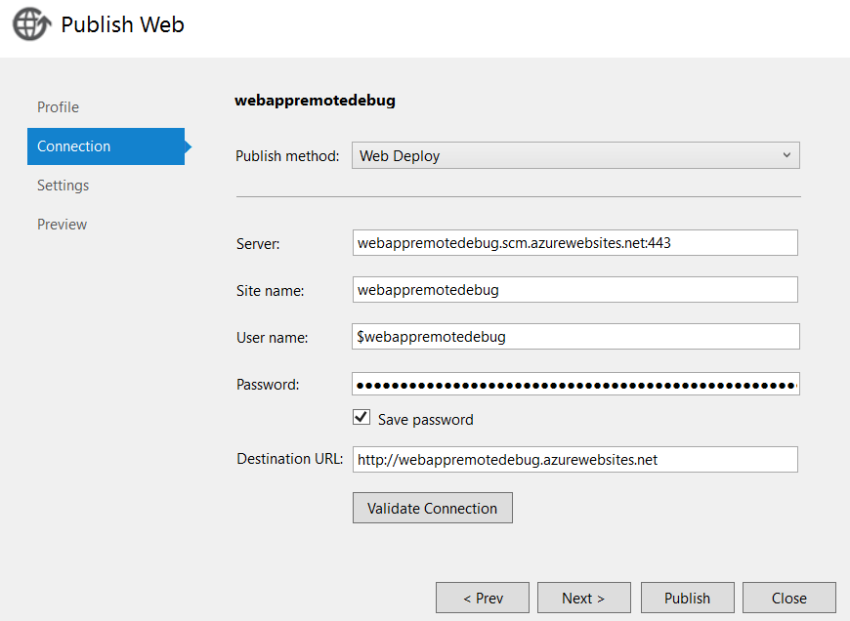

Step 8: Change Configuration to “Debug”

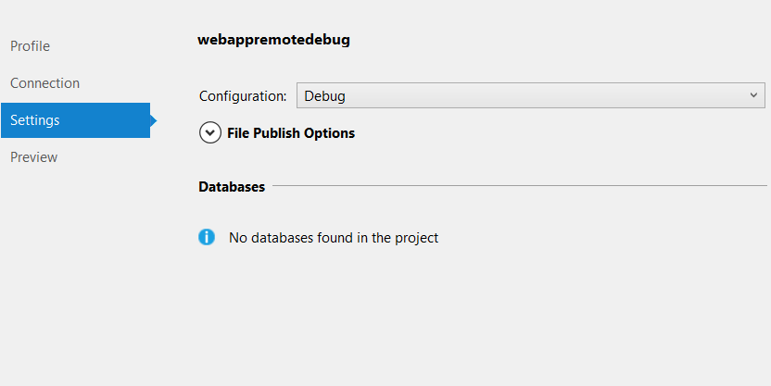

Step 9: Click on Publish button

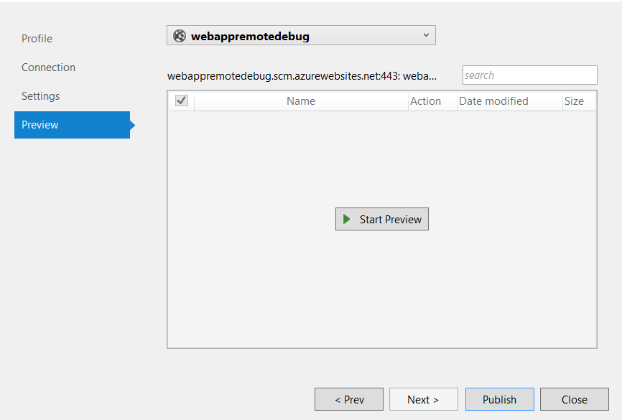

Wait for uploading website on azure

Step 10: When Azure Web App will run Open “Server Explorer” from Visual Studio

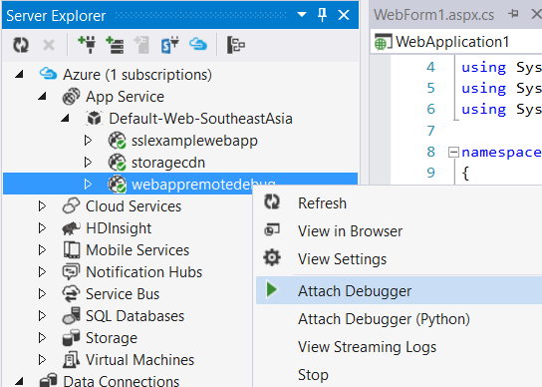

Remote debugging will add on particular web app & automatically web app will open in browser.

